**VISVESVARAYA TECHNOLOGICAL UNIVERSITY**

**“JnanaSangama”, Belgaum -590014, Karnataka.**



**PROJECT WORK-3 REPORT**

**on**

**PROJECT TITLE**

***Submitted by***

**Triveni Y(1BM19CS411)**

**Swathi V(1BM19CS410)**

***Under the Guidance of***

|  |  |
| --- | --- |
| **Prof. Namratha M**  **Assistant Professor, BMSCE** |  |

***in partial fulfillment for the award of the degree of***

**BACHELOR OF ENGINEERING**

***in***

**COMPUTER SCIENCE AND ENGINEERING**



**B. M. S. COLLEGE OF ENGINEERING**

**(Autonomous Institution under VTU)**

**BENGALURU-560019**

**Sep-2020 to Jan-2021**

**B. M. S. College of Engineering,**

**Bull Temple Road, Bangalore 560019**

(Affiliated To Visvesvaraya Technological University, Belgaum)

**Department of Computer Science and Engineering**



**CERTIFICATE**

This is to certify that the project work entitled “**Quiz app**” carried out by **Triveni Y(1BM19CS411) ,Swathi V(1BM19CS410)** who are bonafide students of **B. M. S. College of Engineering.** It is in partial fulfillment for the award of **Bachelor of Engineering in Computer Science and Engineering** of the Visveswaraiah Technological University, Belgaum during the year 2020-2021. The project report has been approved as it satisfies the academic requirements in respect of **Project Work-3 (20CS5PWPW3)** work prescribed for the said degree.

Signature of the Guide                 Signature of the HOD

Prof. Namratha M Dr. Umadevi V

Assistant Professor, Dept. of CSE Associate Prof. & Head, Dept. of CSE

BMSCE, Bengaluru BMSCE, Bengaluru

External Viva

Name of the Examiner                                                                                       Signature with date

1._____________________________ ________________________

2. _____________________________ _________________________

**B. M. S. College of EngineerinG**

**DEPARTMENT OF COMPUTER SCIENCE AND ENGINEERING**



***DECALARATION***

We, Swathi V(1BM19CS410), Triveni Y (1BM19CS411) students of 5th Semester, B.E, Department of Computer Science and Engineering, B. M. S. College of Engineering, Bangalore, here by declare that, this Project Work-1entitled "Project Title" has been carried out by us under the guidance of Dr. Umadevi V, Associate Professor, Department of CSE, B. M. S. College of Engineering, Bangalore during the academic semester Sep-2020-Jan-2021

We also declare that to the best of our knowledge and belief, the development reported here is not from part of any other report by any other students.

Signature

Triveni Y(1BM19CS411) Triveni. y

Swathi V(1BM19CS410) Swathi .v

1. Introduction

Website development for “Online Quiz conduction”.

This Quiz website supports for the students to take up the quiz.

**Functionalities under Student login**

1. The student can login to the website to take up the quiz by entering login credentials.
2. The student can take up the quiz .
3. After taking quiz , they can view the score gained.

2. Design Layouts of web pages

2.1:Home page

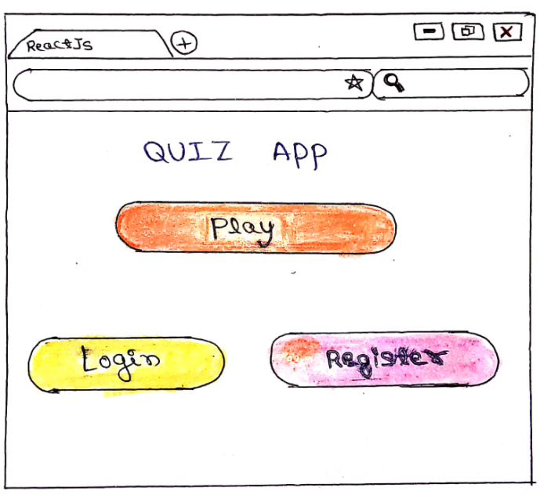

2.2: Registration page

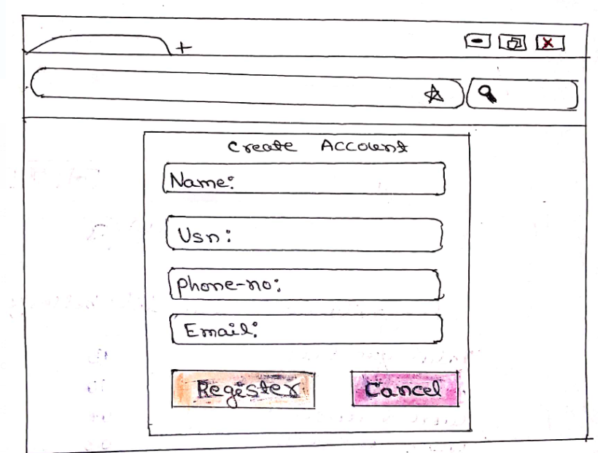

2.3:Login page

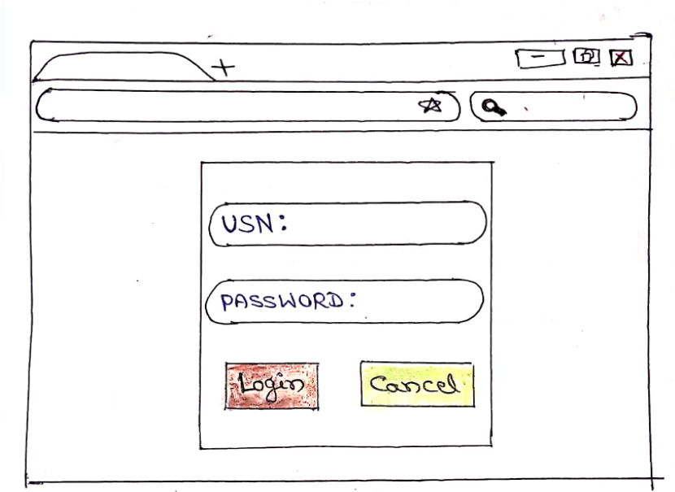

2.4:Taking Quiz

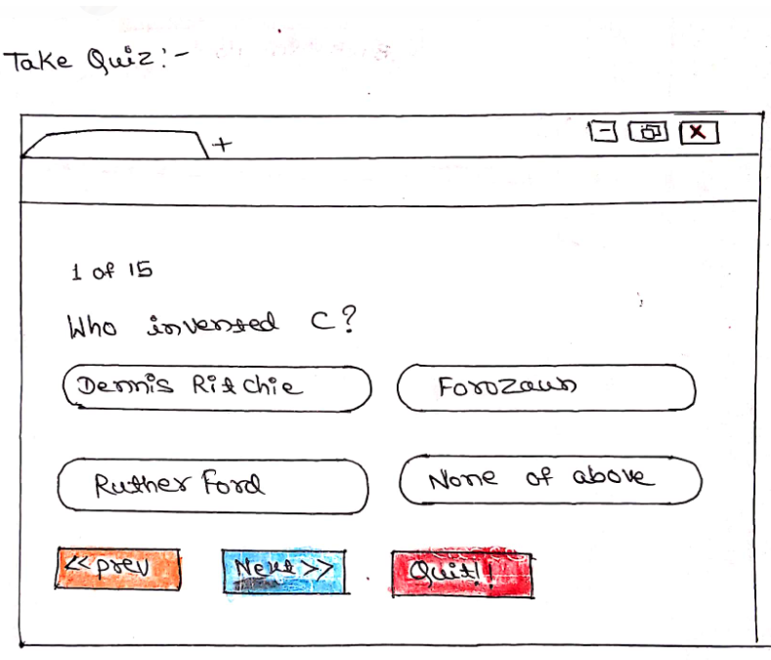

2.5:Score view

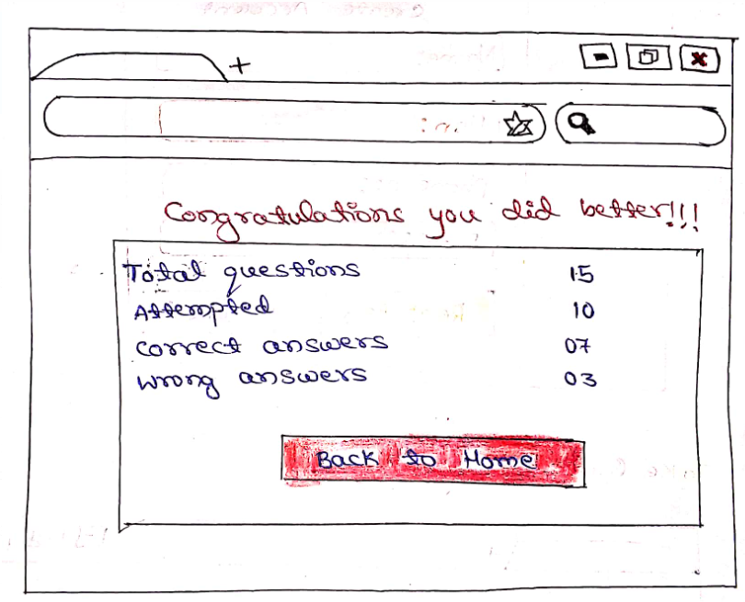

3:Flow chart of the web quiz app

Back to Home

View Score

Take Quiz

Registration

Login

Home